DREAMY CREAMY CHEESECAKE
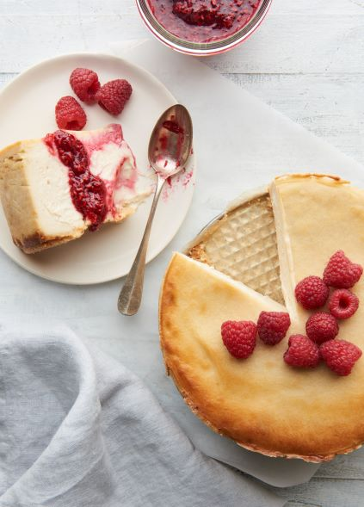
What You'll Need
1 cup raw cane sugar
1 ½ tablespoon cornstarch
16 oz extra firm tofu
8 oz Kite Hill Ricotta
16 oz Kite Hill cream cheese
1 tablespoon vanilla bean paste
1 tablespoon lemon juice or to taste
Pinch of salt

Crust:
1 1/2 cup gluten-free graham crackers (crumbs)
7 tablespoons softened vegan butter
¼ cup cane sugar
1/8 teaspoon salt

Instructions
Step 1. In the bowl of a food processor, blend tofu, cornstarch, and sugar together for 4 minutes until smooth.

Step 2. Add remaining ingredients and continue to blend for another 4 minutes

Step 3. Mix graham cracker crumbs, sugar, melted vegan butter or margarine, and salt until well blended. Press mixture into a 7-, 8- or 9-inch springform pie pan.

Step 4. Bake crust at 325 for 7 minutes until it just starts to brown. Cool completely before filling.

Step 5. Fill with cake batter and bake 375 for 45 minutes - 1 hour until center is set.

Step 6. Cool completely and refrigerate overnight before serving

YIELD: SERVES One 7” cake or five 3” cakes
TIME: 45 minutes. Total time: 24 hours.

